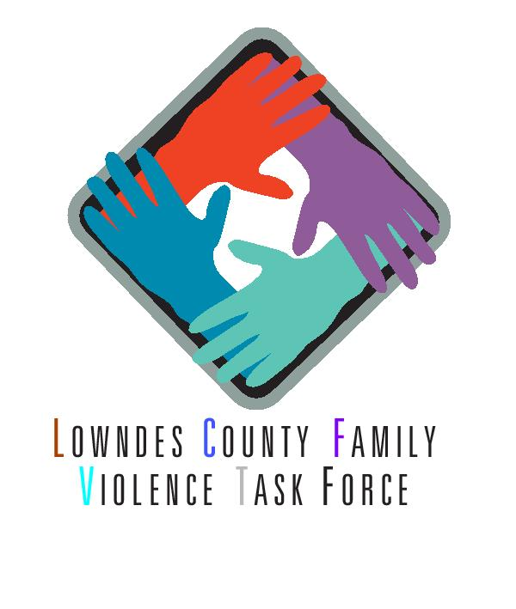

**SAVE THE DATE**

**Join us for our Annual Conference**

October 25, 2018

Valdosta City Annex

8:00 am - 5:00 pm

Topics include:

Suicide Prevention Training (QPR)

Working with Childhood Trauma

Harassment in the Workplace

Legislative Updates

CEU’s Available

*Hosted by LCFVTF*

*Please contact Maggie Miller for more information,* [*mmiller@gocats.org*](mailto:mmiller@gocats.org)